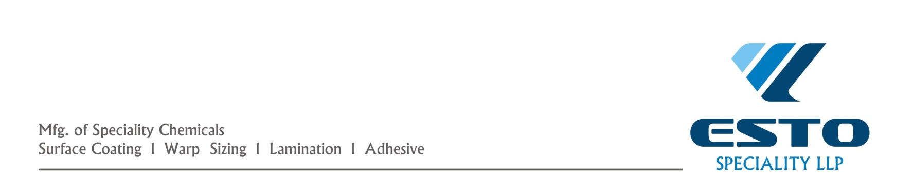

PRODUCT : BLANKET ADHESIVE
A super pressure and temperature sensitive non sticky adhesive for rotary
And flat belt screen printing mashines which removes tackiness and shado
Problems.
APPEARANCE : Transparent, crystal-clear, viscose liquid.
TEMPERATURE: Estoadhe HT-80, Estoadhe-MT-50
SENSITIVITY : Estoadhe-PGMT-40,Estoadhe-LT-30
CHEMICAL PROPERTIES : A solvent based organic polymer
ECONOMY : The cheapest,most economical & high quality adhesive
HOW TO USE :
1 Recommended based coat
First coat : One coat of H.T
Second coat: another coat of H.T after 1 ½ hour of first coat.
Third coat : One coat of M.T & H.T after 2 hour of second coat.
THIS COMPLETES THE BASE COAT
2 Regular coat
One coat of M.T as per requirement.
Note : 1 One coat equals approximately 700 to 800 gms of adhesive.
2 If desired stickiness is not achieved then please add L.T to the regular coat.please add H.T
To the regular coat if the tackiness is more,or consult with your printing master.
PRECAUTION : Please keep the lids of containers tightly closed.
PACKING : 10 Kg

